Lab 10 – Worksheet

Name: Hassan Akhter/ Arham Hussain | ID:ha10609/sh10331 | Section: T1

Note: Assumptions and logics should be explained separately in tasks after the task results.

Task 1
FSM of assembly implementation of FSM designed in Lab 05

FSM FROM LAB 5:

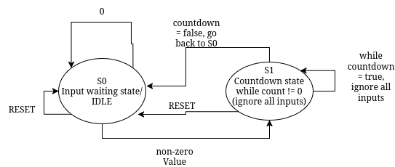
CONTROL FLOW Diagram:
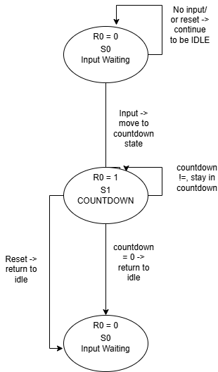

Task 2

Complete assembly source file implementing the FSM.
WORK IN PROGRESS

li t0, 0 # state = INPUT_WAIT
.text
.globl main
main:
beq t0, zero, input_state
li t1, 1
beq t0, t1, countdown_state
j main_loop

input_state:
lw t2, 0(x10) # read switches
beq t2, zero, main_loop

sw t2, 0(x11) # display on LEDs
mv t3, t2 # store count
li t0, 1 # state = COUNTDOWN
j main_loop

countdown_state:
mv a0, t3
jal ra, countdown
li t0, 0
j main_loop

# -------------------------
countdown:
addi sp, sp, -8
sw ra, 4(sp)
sw t0, 0(sp)

loop_cd:
beq a0, zero, done_cd
sw a0, 0(x11)
addi a0, a0, -1
jal ra, delay
j loop_cd

done_cd:
lw t0, 0(sp)
lw ra, 4(sp)
addi sp, sp, 8
jr ra

# -------------------------
delay:
li t4, 10000
dloop:
addi t4, t4, -1
bne t4, zero, dloop
jr ra

Task 3

Design module code of instruction memory module containing memory initialized with assembly instructions:

MACHINE CODE:
0x00000293
0x00028863
0x00100313
0x02628063
0xff5ff06f
0x00052383
0xfe0386e3
0x0075a023
0x00038e13
0x00100293
0xfddff06f
0x000e0513
0x00c000ef
0x00000293
0xfcdff06f
0xff810113
0x00112223
0x00512023
0x00050a63
0x00a5a023
0xfff50513
0x018000ef
0xff1ff06f
0x00012283
0x00412083
0x00810113
0x00008067
0x00002eb7
0x710e8e93
0xfffe8e93
0xfe0e9ee3
0x00008067
RISC V INSTRUCTIONS.MEM FILE ->
93
02
00
00

63
88
02
00

13
03
10
00

63
80
62
02

6f
f0
5f
ff

83
23
05
00

e3
86
03
fe

23
a0
75
00

13
8e
03
00

93
02
10
00

6f
f0
df
fd

13
05
0e
00

ef
00
c0
00

93
02
00
00

6f
f0
df
fc

13
01
81
ff

23
22
11
00

23
20
51
00

63
0a
05
00

23
a0
a5
00

13
05
f5
ff

ef
00
80
01

6f
f0
1f
ff

83
22
01
00

83
20
41
00

13
01
81
00

67
80
00
00

b7
2e
00
00

93
8e
0e
71

93
8e
fe
ff

e3
9e
0e
fe

67
80
00
00
MODULE CODE:
module instructionMemory#(
parameter OPERAND_LENGTH = 31
)(
input [OPERAND_LENGTH:0] instAddress,
output reg [31:0] instruction
);

reg [7:0] memory [0:255];

always @(*) begin
instruction = { memory[instAddress],
memory[instAddress + 1],
memory[instAddress + 2],
memory[instAddress + 3] };
end

// Initialize memory
initial begin
// Load from external file
$readmemh("instructions.mem", memory);
end

endmodule

Lab 10: State-Based Control Flow Using RISC-V Assembly

Points Distribution
Task No. | LR2  Code | LR 5  Results | LR11  Design | AR7
Task 1 | - | - | /20 | /20
Task 2 | /20 | /20
Task 3 | /20 | -
Total Points | /80 |  |  | /20
CLO Mapped | CLO 1
For description of different levels of the mapped rubrics, please refer the provided Lab Evaluation Assessment Rubrics and Affective Domain Assessment Rubrics.
# | Assessment Elements | Level 1: Unsatisfactory  Points 0-1 | Level 2: Developing  Points 2 | Level 3:Good  Points 3 | Level 4:Exemplary  Points 4
LR2 | Program/Code/ Simulation Model/ Network Model | Program/code/simulation model/network model does not implement the required functionality and has several errors. The student is not able to utilize even the basic tools of the software. | Program/code/simulation model/network model has some errors and does not produce completely accurate results. Student has limited command on the basic tools of the software. | Program/code/simulation model/network model gives correct output but not efficiently implemented or implemented by computationally complex routine. | Program/code/simulation /network model is efficiently implemented and gives correct output. Student has full command on the basic tools of the software.
LR5 | Results & Plots | Figures/ graphs / tables are not developed or are poorly constructed with erroneous results. Titles, captions, units are not mentioned. Data is presented in an obscure manner. | Figures, graphs and tables are drawn but contain errors. Titles, captions, units are not accurate. Data presentation is not too clear. | All figures, graphs, tables are correctly drawn but contain minor errors or some of the details are missing. | Figures / graphs / tables are correctly drawn and appropriate titles/captions and proper units are mentioned. Data presentation is systematic.
AR9 | Report | All the in-lab tasks are not included in report and / or the report is submitted too late. | Most of the tasks are included in report but are not well explained. All the necessary figures / plots are not included. Report is submitted after due date. | Good summary of most the in-lab tasks is included in report. The work is supported by figures and plots with explanations. The report is submitted timely. | Detailed summary of the in-lab tasks is provided. All tasks are included and explained well. Data is presented clearly including all the necessary figures, plots and tables.

